BugID:0001

Title: **Login Page | User can't login with valid credentials**

Severity: Critical

Environment: Win10 | Chrome Version 119.0.6045.105

**Steps to reproduce:**

1. Open homepage https://www.saucedemo.com/

2. Enter user: locked_out_user / secret_sauce

3. Click on the Login button.

**Expected result: User can login with valid credentials.**

**Actual result: User can't login with valid credentials. The error message is "Sorry, this user has been locked out.".**

**Screenshots:**

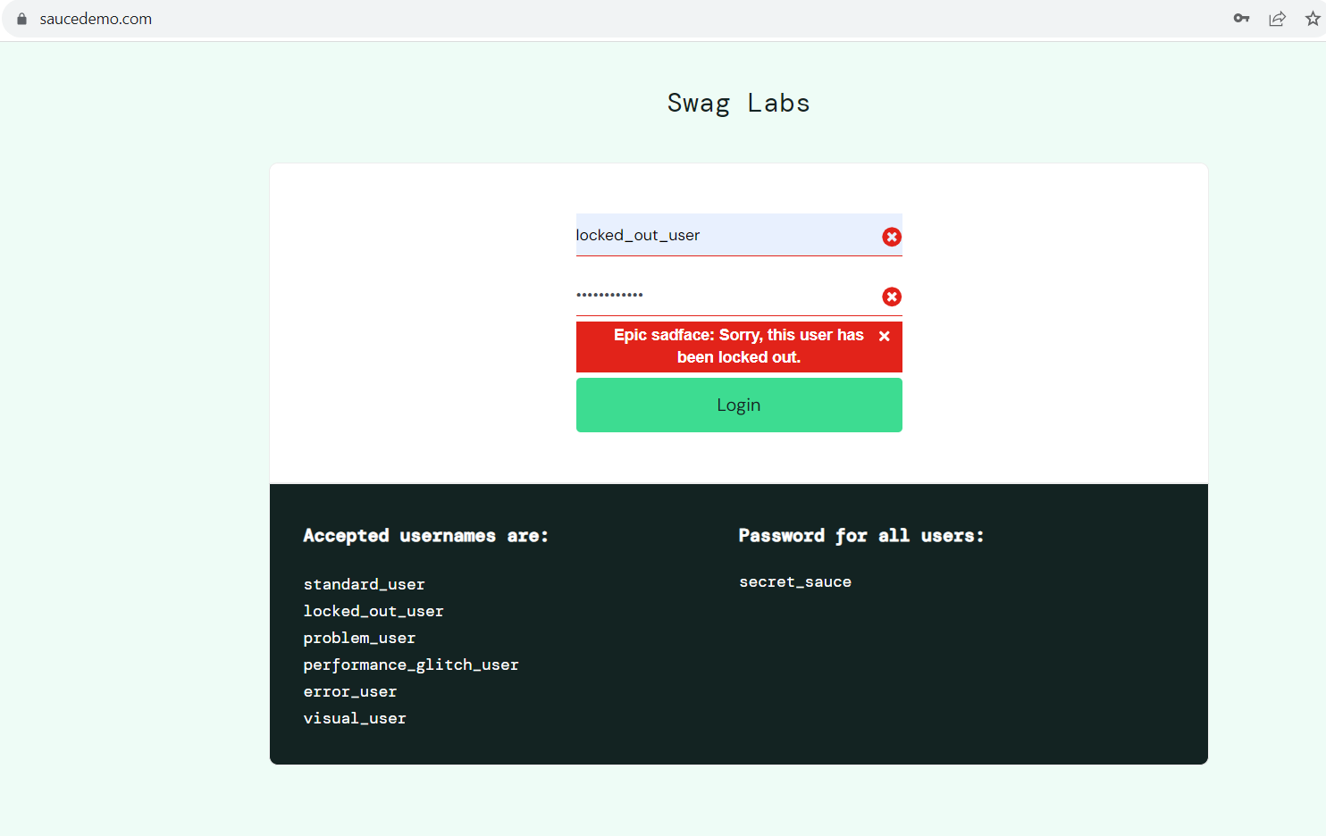

**Video (gif):**

